2002 ENGELHORN GATHERING

Hello again from the 2002 Family Gathering planning committee.
Thanks to all of you who responded to our earlier announcement. 54 family members have said they will join us and another 18 have said they “might” attend. This is great news! We’ll have a super time together.
In order to join us, there are a couple of things you need to do.

First, mail in your registration. The cost is $30 per adult and $15 per child under 12. This fee will cover one big family dinner, our meeting room, and miscellaneous snacks. Personal checks are preferred. (All funds will be spent on Engelhorn family gatherings.) Please register soon; this helps us to make realistic plans. If something happens later and you cannot attend, we will refund as much of your registration as we can, baring commitments we’ve made to the vendors.

Second, make room reservations. This year’s gathering will be held

August 8 – 11, 2002
Superior Shores Resort and Conference Center
Two Harbors, Minnesota
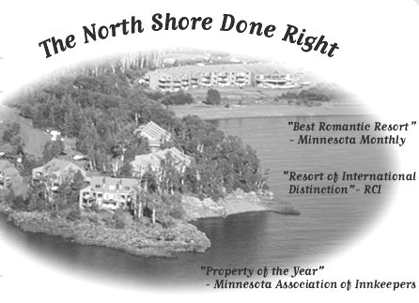
You need to call Superior Shores (800) 242-1988 and make your room reservations. Superior Shores offers a range of lodging, from hotel rooms to multi-room townhouses. Be sure to mention that you are with the Engelhorn Gathering and they will try to keep our rooms near each other. Rates start at $100 per night. If you want to share a room, write a note on your registration form and we’ll try to put you in touch with another single family member. You can read more about Superior Shores on the web at www.superiorshores.com.

Third, make airline reservations to arrive in Duluth, Minnesota. Superior Shores is one mile North of Two Harbors – about 20 miles North of Duluth. At the Duluth airport you can rent a car. If you would like to consider coordinating a ride share, write to us and we can put family members in touch with each other to make plans.

To note: We have made arrangements for a mid-day cruise of the lake on the Grandpa Woo excursion boat for August 9th. We will be cruising North East along the shore to Encampment Island. A pair of Bald Eagles nest there each year. We will be able to see the aerie and possibly the young eagles. Cruise tickets cost about $20 each; These tickets are not included in the registration fee; we are negotiating for a good rate. You can decide on this later. We’ll keep you posted.
We are planning an evening campfire one night. If you have any portable musical instruments (guitars, flutes, drums, etc) bring them along for the campfire.
Many of you expressed an interest in a tour of historic Canal Park; we will try to set one up.
By way of a mixer we thought it would be fun to have a game afternoon / evening. If you have a favorite board game or card game, please bring it along. The best games will be ones that are easy to learn, can be played by six or ten people, and can be played in 30 minutes or so. This will give us a great way to meet each other and chat. If you don’t feel like playing, there’s always room for kibitzing!
This year’s event is shaping up to be an exceptionally good time!

We look forward to seeing you at the gathering,

Jim and Angela, Pete and Kim

Your family reunion contacts are:
Peter Marrier (kip@mb.sympatico.ca) - site liaison / planning
Jim Schrempp (jschrempp@usa.net) - communications / registration
Susan Marrier (smarrier@flash.lakeheadu.ca) - activities

YOUR CHECKLIST:

__ April15 Mail in registration confirmation and fees
__ May 15 Make room reservations at Superior Shores (800) 242-1988 resort
__ May 15 Make airplane reservations
__ July 15 Select a fun game to bring
__ August 6 Pack your suitcase

ENGELHORN GATHERING REGISTRATION

Return to: Engelhorn Gathering
c/o Jim Schrempp
14587 Oak Street
Saratoga, CA 95070 USA

Please return by April 15. Make your check payable to: Jim Schrempp

Family Contact Name:
Phone Number:
Address:
City: | State: | Zip:

 | Number of people | Cost per person | Sub Total
Adults |  | $30 each
Children |  | $15 each
 |  | Total Cost

We plan to publish a list of attendees. May we list your address and phone number so others attendees can contact you? YES NO .

Please list the names of each person you are registering:

- Name: Adult / Teen / Child
- Name: Adult / Teen / Child
- Name: Adult / Teen / Child
- Name: Adult / Teen / Child
- Name: Adult / Teen / Child

